Table (3) Production Lines and Service Units
Production Lines | Service Units
- Phosphatic Fertilizers | Boilers
- Super phosphate production | Water treatment unit
- Triple superphosphate production | Wastewater treatment plant
- Phosphoric acid production | Compressors
- Sulphuric acid production | Cooling towers
- Nitrogenous Fertilizers | Storage facilities
- Ammonia production | Workshops
- Nitric acid production | Garage
  - Ammonium nitrate production
  - Diammonium phosphate production
  - Ammonium sulphate production
  - Urea production
  - Methanol
  - Calcium nitrate

Phosphates Fertilizers
Phosphate fertilizers industry is considered one of the most polluting industries in Egypt. No modernization or pollution abatement plans and technologies were set for this industry, in spite of the implementation of such technologies world wide. It is worth mentioning that the production of phosphate fertilizers in Egypt is limited (installed capacities 1.2 millions tons 15.5 P₂O₅) compared with nitrogenous fertilizers (installed capacities 12 million tons estimated as 15 % N₂).

The various phosphate fertilizers, depending on their composition, have different solubility in soil solutions and are, therefore, assimilated by plants differently. Phosphate fertilizers include single superphosphate and triple superphosphate. The single superphosphate is a mixture of monocalcium phosphate and gypsum (available P₂O₅ almost 16- 22 %), while triple-superphosphate is composed mainly of monocalcium phosphate (available P₂O₅) almost 46 %).

a) Single supephosphate Fertilizer
Fig (1) presents the block flow diagram for manufacturing of mono superphosphate fertilizers and the related raw materials and pollution sources.

The manufacturing process depends on reacting phosphate rock with sulfuric acid and the fertilizer contains about (16- 20 %) P₂O₅. The net reaction proceeds as follows:

Ca F₂. 3Ca₃ (PO₄)₂ + 7H₂SO₄ + 14H₂O → 3Ca(H₂PO₄)₂ + 7Ca SO₄ . 2H₂O + 2HF

The process can be divided into two stages as follows:
- The first stage represents the diffusion of sulfuric acid to the rock particles accompanied by a rapid chemical reaction on the particle surface, which continues until the acid is completely consumed, and crystallization of calcium sulphate.
- The second stage represents the diffusion of the formed phosphoric acid into the pores of the rock particles which did not decompose. This stage is accompanied by a second reaction.

In this process ground phosphate rock is transported from the storage site to automatic weight, by a system of belt and screw conveyors and elevators, which feed the continuous action double conical mixer. The sulfuric acid is continuously diluted with water in a batch mixer to a 75 % concentration, then fed to the mixer to react with ground phosphate rock where a first reaction takes place. This reaction ends in the reaction mixer in 30- 60 minutes, during the period of settling and hardening of the superphosphate slurry, which is caused by the relatively rapid crystallization of the low solubility calcium sulphate. The next stage of the process is ageing of the superphosphate, i.e. the formation and crystallization of monocalcium phosphate in the den. The formed slurry is transported to the continuous-action reaction den which has a very low travel speed to allow for solidifying (see fig 2), where formation of superphosphate takes place (settling and hardening of the slurry in the first stage of ageing). Considerable quantities of fluoride compounds are evolved from the acidulation, they are sent to the scrubbers shown in fig (3).

The superphosphate powder, from the den, is transferred for ageing by a belt conveyor, located below the den, to the pile storage for curing, or completion of chemical reaction, which takes 2-6 weeks to a P₂O₅ availability acceptable for plant nutrient. The raw fertilizer is uniformly distributed by a scattering device and in order to accelerate the ageing operation, the superphosphate is agitated during storage by means of a grab-bucket crane. The end product still contains a certain amount of uncombined phosphoric acid, which makes the fertilizer more hygroscopic. Neutralizing admixtures are used to remove the free acid of the superphosphate, or it is treated with gaseous ammonia. These procedures improve the physical properties of the superphosphate. They lower the moisture content, the hygroscopic and the tendency to cake. If ammonia treatment is used, an additional nutritional component (N₂) is also introduced into the fertilizer.

During reaction of the phosphate with sulphuric acid in the den, hydrogen fluoride evolves and reacts with the silica contained in the phosphates and forms gaseous silicon-tetrafluoride (SiF₄) and fluo slicic acid (H₂SiF₆). The continuous den is, therefore, enclosed so that fumes of these compounds do not escape into the working place. The fluorous gases, containing H₂SiF₆ vapors, are withdrawn through an opening in the den roof into a ventilation pipe to an absorption unit and are utilized for making sodium fluo silicates.

Superphosphate is granulated in drum granulators to improve its physical properties. In the granulator, the superphosphate powder (after being cured for 2-6 weeks) is wetted with water fed into the drum through nozzles, and rolled into granules of different size which are then dried, screened into size fractions cooled and the product is bagged in plastic (polyethylene) bags. The over size granules are ground and recycled, with the undersize granules, to the den.

Fig (1) Process Flow Diagram for Single Superphosphate Manufacturing
Inputs | Operations | Outputs
Crushing, Grinding & screening  Acidulation Mixer  Bagging of SSP Powder  Drum Granulation  Screening  Cooling  Bagging of SSP  Granules  Dilution  Reaction Den  Belt Conveyor  Storage for curing (2-6 weeks)  Phosphate Rock |  | Dust & particulates  Noise (work place)
75 % H₂SO₄  Water |  | Heat
Hydrogen Fluoride (HF) + acid mist (to scrubber)
SiO₂
HF, H₂SiF₆ vapours, CO₂, SiF₄ and SiO₂
(to scrubber)
Dust, particulates
(work place)
 |  | Particulates and gaseous fluorides (work place)
Polyethylene Bags |  | Particulates (work place)
Water |  | Dust & Fumes (to the scrubber)
 |  | Particulates
Cooling air
Polyethylene bags |  | Particulates  (work place)
 | Single Superphosphate

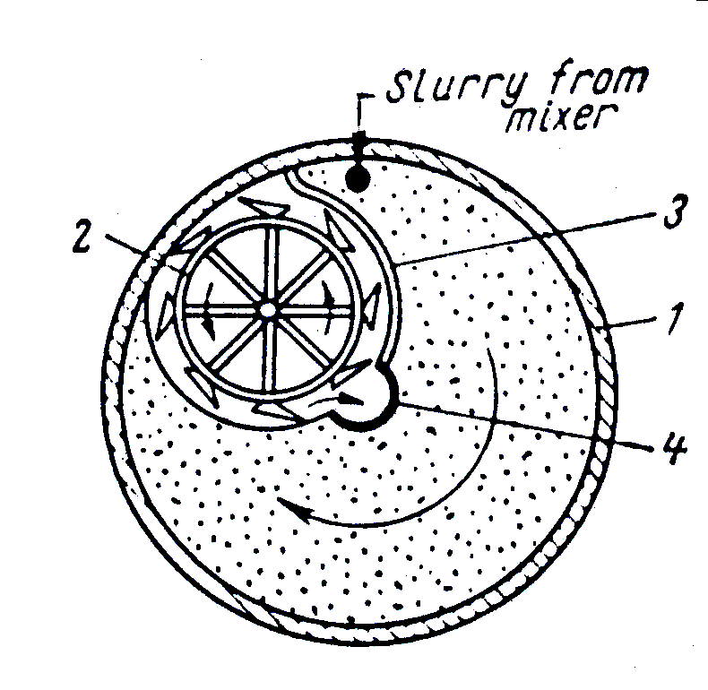

Fig (2- a) Continuous- Action Single Superphosphate Den

(1) rotating shell; (2) cutter; (3) partition; (4) stationary discharge pipe

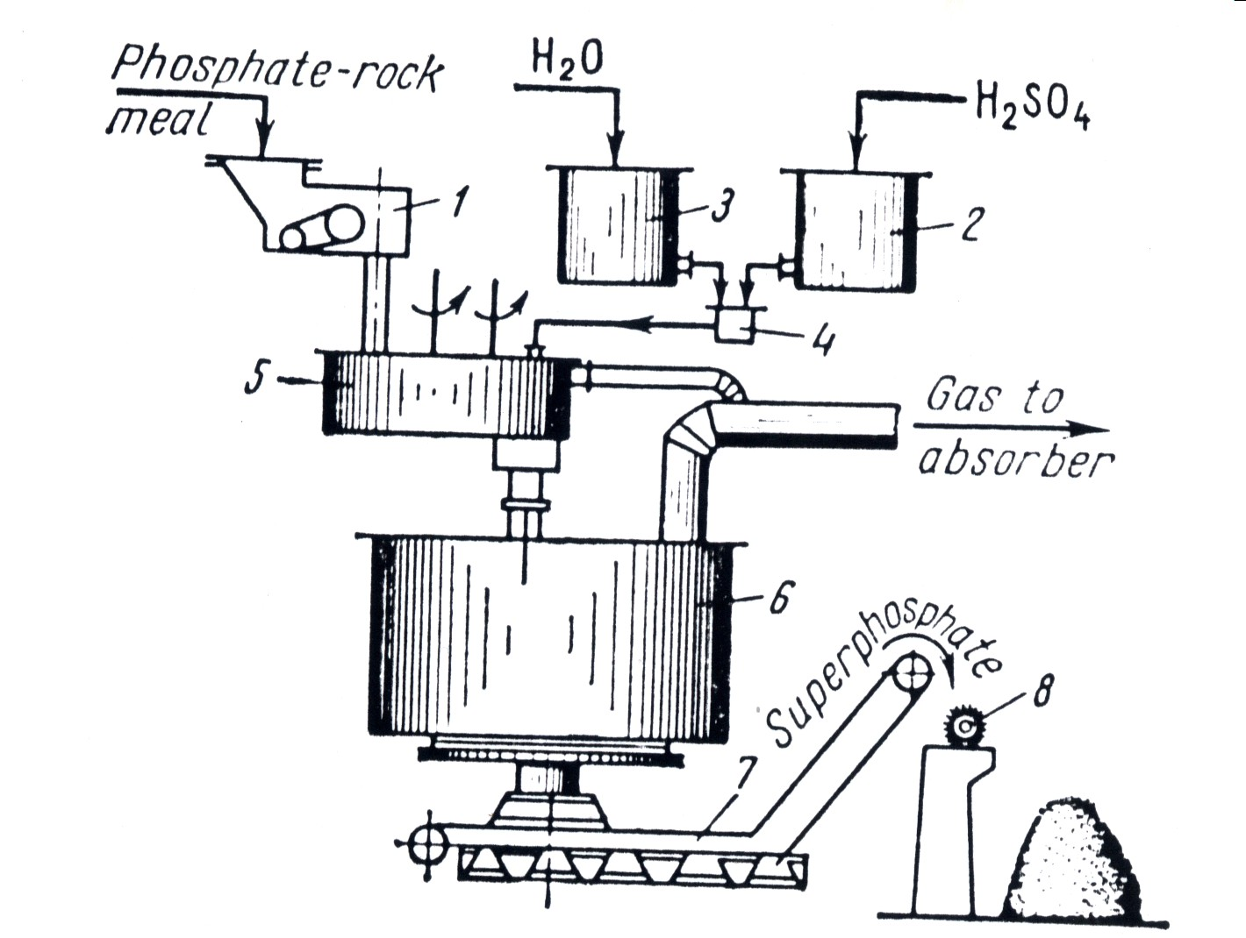

Fig (2- b) Single Superphosphate Manufacturing Processing

(1) phosphate weigh feeder; (2, 3) head tank for sulphuric acid and water; (4) acid feeder; (5) mixer; (6) superphosphate den; (7) superphosphate conveyor; (8) supephosphate scatter at the storage site

Fig 3

b) Triple Superphosphate Fertilizer
Fig (4) shows the block flow diagram for manufacturing of triple superphosphate. This type of fertilizers is much more concentrated than the ordinary superphosphate, containing 45- 46 % of available P₂O₅. Triple superphosphate is manufactured by the action of phosphoric acid on phosphate rock. The main reaction is:

CaF₂. 3Ca₃ (PO₄)₂ + 14H₃PO₄ → 10Ca (H₂PO₄)₂ + 2HF ↑
(Phosphate Rock) (Triple Superphosphate)

A process similar to single superphosphate production is used, in which pulverized phosphate rock is mixed with phosphoric acid in a two-stage reactor. The resultant slurry is sprayed into the granulator. The slurry is sprayed into the drum granulation co-current with flue gases of fired fuel (natural gas or fuel oil and air). The product is screened and off-size is recycled back to the granulator. The on-size product is cooled and stored ready for being bagged. The exhaust gases from the reactor, granulator and cooler are scrubbed to remove fluoric compounds.

Fig (4) Process Flow Diagram for Triple Superphosphate Manufacturing
Inputs | Operations | Outputs
Two-Stage  Reaction  Granulation  Screening  Cooling  Storage & Bagging  Crushing, Grinding & Screening  Phosphate Rock |  | Noise  Dust & Particulates
Phosphoric Acid |  | HF, SiF₄ emissions  (to scrubber)
Water  Recycled over & under size  Burners (direct heat) |  | Water Vapor  Particulates  Emissions (HF, SiF₄)  (to scrubber)  Combustion flue gases
 |  | Particulates
Cold Air |  | Cooling water (to cooling towers)
Polyethylene bags |  | Emissions (HF, SiF₄)  Particulates
 | Granulated Triple Superphosphate

c) Wet Process of Phosphoric Acid Production
The main process for producing phosphoric acid is by the use of sulfuric acid as shown in fig (5). The major reaction is

Ca F₂. 3Ca₃ (PO₄)₂ + 10H₂SO₄ + 20H₂O → 10CaSO₄. 2H₂O + 2HF + 6H₃PO₄
(Phosphate Rock) (Gypsum)

Raw phosphate rock, ground to less than 200 mesh size, is fed to a chute where a recycled stream of weak H₃PO₄ washes it into a reaction tank and digested with strong sulfuric acid. The retention time ranges from 1.5 to 12 hr, and conditions are controlled to produce gypsum crystals that are readily filterable. Considerable heat is generated in the reactor when the sulphuric acid and phosphate rock react. In older plants, this heat was removed by blowing air over the hot slurry surface. In modern plants, a portion of the slurry is cooled by vacuum flash, and then recycled back into the reactor. The reaction mixture is filtered using a tilting-pan filter. The feed to the filter continuously enters the pans, which are connected to the vacuum source. The circular frame supporting the pans rotates so that each pan is moved successively under the desired number of washes. After the final wash liquor has completely drained off, the vacuum is released and the pan is inverted a full 180 degree. The cake drops off, its removal is being ensured by a reverse blast of air through the filter medium, which is then scoured fresh and cleaned by a high-pressure shower while the pan is still inverted. The filter medium and drainage area are then purged by vacuum, and the pan returned to the feed position.

This process produces 28 to 32 % acid which must be concentrated in an evaporator, to meet phosphate feed material specifications for fertilizer production. The crude acid is often black and contains dissolved metals and fluorine, and dissolved and colloidal organic compounds. Suspended solid impurities are usually removed by settling. Solvent extraction or solvent precipitation is used to remove the dissolved impurities. Solvent extraction uses a partially miscible solvent, such as n-butanol, iso-butanol, or n-heptanol. The phosphoric acid is extracted and the impurities are left behind. Back-extraction with water recovers the purified phosphoric acid. Solvent precipitation uses a completely miscible solvent plus alkalis or ammonia to precipitate the impurities as phosphate salts. After filtration, the solvent is separated by distillation and recycled.

Major Hazards
The chance of an acid spill from storage tanks is very small, with the highest risk being a leak from the tank because of corrosion. Corrosion with Phosphoric acid is a relatively slow process and starts with a small hole in the tank. Normally the leak will be seen and the tank emptied before a significant spillage can take place. There is also a risk of the loading pipe cracking during acid loading and this could lead to a significant uncontrolled spillage. Pumping equipment should be available for emptying the pipes.

The more important considerations in the design and construction of phosphogypsum disposal areas are: site selection, cooling ponds and percolation control. The height of the stack depends on the engineering properties of the underlying soil and its load bearing strength, if there are no legal restrictions. The cooling pond surfaces will have to be adapted to local climatic conditions and the water balance in the plant. The process water associated with phosphogypsum is highly acidic and contains high levels of contaminants. some of the following options may be necessary to prevent this water reaching the surrounding ground water system: seepage collection ditches, intercept wells, natural barriers, lining systems (natural or synthetic) and fixing of soluble P₂O₅ and trace elements by neutralization.

Fig (5) Process Flow Diagram for Phosphoric Acid Manufacturing

(Wet Process)
Inputs | Operations | Outputs
Reaction  Filtration  (Vacuum Pan filter)  Grinding  Washing  Gypsum Wash  Settling Pond  Vacuum Evaporation  Settling  Extraction  Separation  Back Extraction  Solvent Recovery  Phosphate Rock |  | Dusts & Particulates  Noise (work place)
Diluted Phosphoric Acid
Strong Sulphuric Acid |  | Fluorides (HF, SiF₄) and acid mist (to the scrubber)
Process Water |  | Acid fumes emissions  Wastewater recycled to reactor (rich in sulphuric acid)
Process Water |  | Wash water (recycled to the reactor)  Fluoride emissions to air
 | Gypsum | Wash water (recycled to the reactor)  Fluoride emissions to air
 | Phosphoric Acid (54 %) | Condensates  Emissions (SiF₄)
 |  | Solid wastes
Solvent (n-butanol/ iso-butanol), ammonia and alkali

 |  | Solid waste impurities (metals, fluorine colloidal organic compounds)
Water

 | Phosphoric Acid

